**EXPERIMENT-1(A)**

**AIM: Discuss about event discrete simulation and its tools.**

**SYSTEM:**

A system is a group of interacting or interrelated entities that form a unified whole. [1] A system, surrounded and influenced by its environment, is described by its boundaries, structure and purpose and expressed in its functioning.

**DISCRETE AND CONTINUOUS**

**Discrete model:** the state variables change only at a countable number of points in time. These points in time are the ones at which the event occurs/change in state.

**Continuous:** the state variables change in a continuous way, and not abruptly from one state to another (infinite number of states).

**WHAT IS SIMULATION AND WHY DO WE NEED IT?**

In [computer network](https://en.wikipedia.org/wiki/Computer_network) research, network simulation is a technique whereby a software program models the behavior of a network by calculating the interaction between the different network entities (routers, switches, nodes, access points, links etc.). Most simulators use discrete event simulation - the modeling of systems in which state variables change at discrete points in time. The behavior of the network and the various applications and services it supports can then be observed in a test lab; various attributes of the environment can also be modified in a controlled manner to assess how the network / protocols would behave under different conditions.

A simulator is a collection of hardware and software systems which are used to mimic the behavior of some entity or phenomenon. Typically, the entity or phenomenon being simulated is from the domain of the tangible -- ranging from the operation of integrated circuits to behavior of a light aircraft during wind sheer. Simulators may also be used to analyze and verify theoretical models which may be too difficult to grasp from a purely conceptual level. Such phenomenon range from examination of black holes to the study of highly abstract models of computation. As such, simulators provide a crucial role in both industry and academia.

Despite the increasing recognition of simulators as a viable and necessary research tool, one must constantly be aware of the potential problems which simulators may introduce. Many of the problems are related to the computational limitations of existing hardware platforms but are quickly being overcome as more powerful platforms are introduced. Other problems, unfortunately, are inherent within simulators and are related to the complexity associated with the systems being simulated. This section highlights some of the major advantages and disadvantages posed by modern day simulators.

**DISCRETE EVENT SIMULATION**

Discrete event simulation (DES) is a method of simulating the behavior and performance of a real-life process, facility or system. DES is being used increasingly in health-care services24–26 and the increasing speed and memory of computers has allowed the technique to be applied to problems of increasing size and complexity. DES models the system as a series of ‘events’ [e.g. a birth, a stay in an intensive care unit (ICU), a transfer or a discharge] that occur over time. DES assumes no change in the system between events. In DES, patients are modelled as independent entities each of which can be given associated attribute information. In the case of neonatal simulation this may include parameters such as gestational age or weight at birth, hospital of birth, singleton/twin and current location.

The information may be modified as time runs in the simulation model (e.g. the location will be changed depending on the status of the units in the network, and the level of care being received will be modified as the infant progresses). The simulation also accounts for resources. In the neonatal model the key resources are cots (with the highest level of care for each cot specified) and nurses. In order to care for an infant a unit must have the necessary cot and the necessary nursing staff (applying appropriate guidelines). The model allows each unit to work to a specified level of overcapacity regarding nursing, but will monitor the time each unit is undergoing overcapacity. DES models also allow for complex rules specifying where infants may be accepted; for example, there may be two ICUs, but with different facilities (e.g. surgery) or with different limits on gestational ages. DES thus allows complex decision logic to be incorporated that is not as readily possible in other types of modeling.

**TOOLS OF EVENT DISCRETE EVENT SIMULATION**

1. **NS2** is an open-source simulation tool that runs on Linux. It is a discreet event simulator targeted at networking research and provides substantial support for simulation of routing, multicast protocols and IP protocols, such as UDP, TCP, RTP and SRM over wired and wireless (local and satellite) networks.
2. **Ns-3** is a discrete-event network simulator for Internet systems, targeted primarily for research and educational use. Ns-3 is free software, licensed under the GNU GPLv2 license, and is publicly available for research, development, and use. Docs. App Store.
3. **OMNeT++** is a modular, component-based C++ simulation library and framework, primarily for building network simulators. OMNeT++ can be used for free for non-commercial simulations like at academic institutions and for teaching. OMNEST is an extended version of OMNeT++ for commercial use cases.
4. **ns-1**: The first version of ns, known as ns-1, was developed at Lawrence Berkeley National Laboratory (LBNL) in the 1995-97 timeframe by Steve McCanne, Sally Floyd, Kevin Fall, and other contributors. This was known as the LBNL Network Simulator, and derived in 1989 from an earlier simulator known as REAL by S. Keshav.
5. **NetSim** is an end-to-end, full stack, packet level network simulator and emulator. It provides network engineers with a technology development environment for protocol modeling, network R&D and military communications. The behavior and performance of new protocols and devices can be investigated in an virtual network within NetSim at significantly lower cost and in less time than with hardware prototypes.
6. **The QualNet**  network simulation software (QualNet) is a planning, testing, and training tool that “mimics” the behavior of real communication networks. Network simulation is a cost-effective method for developing, deploying, and managing network-centric systems throughout their entire lifecycle.
7. **SIM.JS** is an event-based discrete-event simulation library based on standard JavaScript. The library has been written in order to enable simulation within standard browsers by utilizing web technology. SIM.JS supports entities, resources (Facility, Buffers and Stores), communication (via Timers, Events and Messages) and statistics (with Data Series, Time Series and Population statistics).The SIM.JS distribution contains tutorials, in-depth documentation, and a large number of examples.SIM.JS is released as open source software under the LGPL license. The first version was released in January 2011.

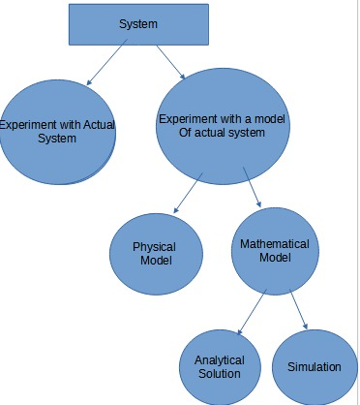

**SYSTEM IMPLEMENTATION AND STUDY**

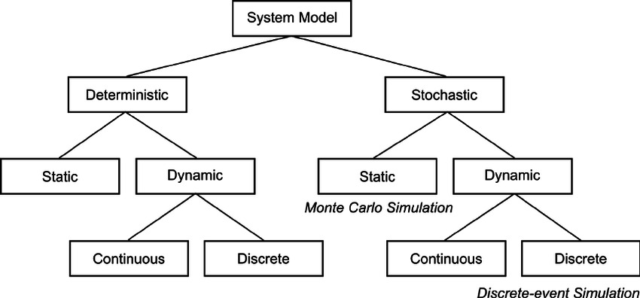

**MODEL TAXTONOMY**